**Table of Contents**

0. Preface 2

1. Introduction 2

1.1 Overview 2

1.2 Quickstart 2

2. The Interface 2

2.1 Overview 2

2.2 Dropdown Menus and Toolbar 3

2.3 The Toy Box 4

2.4 The Sandbox 5

3. Working in Design Mode 5

3.1 Adding a Component 5

3.2 Working with Wires 5

3.3 Selecting and Moving Objects 6

3.4 Deleting Objects 6

3.5 Creating Custom Components 6

4. Working in Simulation Mode 7

5. Troubleshooting 7

6. Glossary 8

# 0. Preface

This user manual describes the basics of how to use *Circuit Sandbox*, developed by Daniel Stahl and Kevin Wellwood.

# 1. Introduction

## 1.1 Overview

*Circuit Sandbox* is designed for the creation and simulation of virtual logic circuits. Program operation is composed of two modes--design mode and simulation mode. Circuits are created in design mode by placing components (inputs, outputs and logic gates) and connecting them. In simulation mode, the behavior of the circuits is simulated in real time.

## 1.2 Quickstart

Open a terminal window and navigate to the folder containing the *Circuit Sandbox*.jar file. Enter the command

java –jar CircuitSandbox.jar

Alternatively, browse to the *Circuit Sandbox* folder with Explorer (Windows) or Finder (Macintosh) and double click on the CircuitSandbox.jar file.

# 2. The Interface

## 2.1 Overview

The interface is made up of the following parts:

|  |  |
| --- | --- |
| **Dropdown menus** | These are used to perform all general program operations, such as opening and saving a model, and switching between design mode and simulation mode. |
| **The Toolbar** | This is a group of buttons used to perform most common operations. |
| **The Toy Box** | This is an organized collection of components used to build circuits, located on the left side of the window. |
| **The Sandbox** | This is the space for creating and simulating the operation of circuits. This comprises the majority of the program window. |

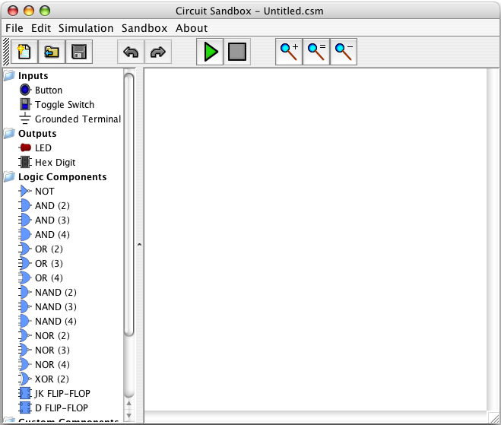

Sandbox

Toy Box

Toolbar

Dropdown Menus

*Figure 2.1: The Interface*

## 2.2 Dropdown Menus and Toolbar

The following is a list of commands that are available from the dropdown menus. Frequently used commands are also available as buttons on the toolbar.

|  |  |  |
| --- | --- | --- |
| **File Menu** | | |
|  | New Model | Create a new model. Only one model can be open at a time. If there are unsaved changes to the model, a prompt to save changes will be displayed, and the current model will be closed. |
|  | Open Model… | Open a previously saved model. |
|  | Load Custom Component… | Load a custom component into the toy box. |
|  | Save | Save the current model. If the model has never been saved, a prompt to enter a file name and location will be displayed. |
|  | Save As… | Save the model with a new name and location. |
|  | Save As Custom Component… | Save the contents of the sandbox as a custom component. |
|  | Export Model As Image… | Save the model as an image. |
|  | | |
| **Edit Menu** | | |
|  | Undo | Undo the most recent action. |
|  | Redo | Redo the most recently undone action. |
|  | Delete | Delete the current selection. |
|  | | |
| **Simulation** | | |
|  | Start Simulation / Stop Simulation | Start or stop the simulation. |
|  | Simulation Speed | Change the simulation speed. |
|  | | |
| **Sandbox** | | |
|  | Zoom In | Increase magnification of the sandbox. |
|  | Zoom Out | Decrease magnification of the sandbox. |
|  | Reset Zoom | Reset magnification to 100%. |
|  | Show Grid | Toggle the sandbox's grid display. The grid is always active, even when it is not shown. |
|  | | |
| **About** | | |
|  | About… | Display the application version and authors. |

## 2.3 The Toy Box

This is where components used to create circuits are located. The components are grouped into four categories:

* Inputs
* Outputs
* Logic Components
* Custom Components

There are three ways to load custom components into the toy box:

1. At program startup, the custom components in the components folder under the *Circuit Sandbox* folder will be automatically loaded into the toy box.
2. When a circuit model using custom components is opened, the components that it uses will be automatically loaded into the toy box.
3. By selecting **Load Custom Component…** from the **File** menu or right clicking (Cmnd-clicking on a Mac) on the toy box, a custom component or folder of custom components can be loaded.

Custom Components can be unloaded by right clicking on the component in the toy box and selecting **Unload Component**. Unloading a component that is used by the current circuit model will not have any effect on the model.

## 2.4 The Sandbox

This is where circuits are constructed and simulated. The magnification can be changed at any time using **Zoom In / Zoom Out** commands in the **Sandbox** menu. All objects within the sandbox can be selected, moved, and deleted in design mode.

# 3. Working in Design Mode

## 3.1 Adding a Component

Available components can be found in the toy box on the left side of the window. To add a new component to the circuit model, click on it. The cursor will now resemble the selected component. To add the component to the circuit model, click the desired location in the sandbox. To cancel adding the component, right click (Cmnd-click on a Mac) or press the Escape key. After the component has been added to the sandbox, it will become unselected in the toy box.

## 3.2 Working with Wires

Each component has two types of connection points: inputs and outputs. For all built-in components, the inputs are on the left and the outputs are on the right. (It is recommended that custom components follow this convention as well, however, it is not required.) Inputs can only be connected to outputs. Only one wire can be attached to an input pin but many wires can be attached to an output pin. To create a wire between two connection points, click on the first connection point, click on the sandbox in any other places to create wire path nodes (or bends in the wire), and finally click on the second connection point. If you wish to cancel creating a wire without clicking on the second connection point, move the mouse out of the sandbox area or press the Backspace key.

Wires do not need to be straight from point A to point B. Wire path nodes can be added to the wire. To add a new wire path node, right click (Cmnd-click on a Mac) on a segment of the wire.

To delete a wire, click on a single segment to select the wire, then press the Backspace key.

## 3.3 Selecting and Moving Objects

To select a single object, click on it. To add objects to the current selection, shift click on another object. To select all objects within a rectangular area, click and drag a box around the desired region. All objects completely within the region will become selected. Shift click and drag to add the components in an area to the current selection. To clear the selection, click on an empty area of the Sandbox.

Selected objects can be moved by clicking and dragging them. When components are moved, all wires will remain attached. The objects in the current selection will move together.

## 3.4 Deleting Objects

To delete all selected objects, press the Backspace key or choose **Delete** from the **Edit** menu. If a component is deleted, all wires connected to it will also be deleted.

## 3.5 Creating Custom Components

A circuit model can be saved as a single custom component, which will look and behave similarly to standard logic gates. This is useful if for:

1. Simplifying the way a circuit model looks
2. Reusing a construct multiple times in the circuit
3. Reusing a construct in a different circuit model

To create a custom component:

1. Create a new model containing the circuit(s) that will go inside the component. All input pins for the new custom component should be connected to input components (e.g buttons). Similarly, all output pins for the custom component should be connected to output components (e.g. LEDs). Holding the mouse over an input or output component will display a tooltip with the ID number of the component. Record these numbers for future reference.

Image Area

1. Select **Save As Custom Component…** from the **File** menu. A dialog box, similar to the one in Figure 3.5, will be displayed.
2. Enter a name for the component in Component Name field. This is the name that will later be displayed along with the custom component image in the toy box.

*Figure 3.5: Creating a Custom Component*

1. An image to be associated with the custom component can also be selected. The image area will initially contain a default image. To replace this image, click the Browse button and select another image. Alternately, the image can be copied to the clipboard for editing with a third-party program. The contents of the clipboard can be pasted to replace the currently displayed image using the standard OS copy and paste shortcuts.
2. The locations of the input and output pins will be represented as colored circles in the component image area. These dots show the locations where wires will be connected to the new custom component. By default, input pins will be displayed on the left and output pins on the right. The pins can be rearranged by dragging and dropping. Moving the mouse over a pin will display the ID number of the input or output component in the circuit model that is currently representing the pin. Refer to step 1 for additional info.
3. Click the Save button and choose a location and file name within the *Circuit Sandbox* components folder. The component may be saved to a subfolder of the components folder. The custom component will appear in the toy box after it has been successfully saved.

# 4. Working in Simulation Mode

Simulation mode simulates the behavior of the current circuit model. Black wires carry an undefined value; red wires carry the Boolean value *True*; and blue wires carry the Boolean value *False*.

To start simulating, select **Start Simulation** from the **Simulation** menu. To change a circuit’s input values, click on the circuit’s input components.

# 5. Troubleshooting

There are several times when a box with an error message may pop up. The following is a list of error messages and possible solutions:

* *Model not opened: File not found*

The selected model file could not be found.

* *Model not opened: Component not loaded: File not found*

The selected model file references a custom component that could not be loaded. The custom component file either doesn’t exist or itself references another custom component that could not be loaded.

* *Model not saved*

The circuit could not be saved to disk. The disk may be out of free space or the path specified may not exist.

* *Component not loaded: File not found*

The selected custom component could not be loaded. The custom component file either doesn’t exist or references another custom component that could not be loaded.

* *Component not saved*

The circuit could not be saved to disk as a custom component. The disk may be out of free space or the path specified may not exist.

# 6. Glossary

|  |  |  |
| --- | --- | --- |
| **Circuit** | … | The visible collection of components and wires in the Sandbox. |
| **Component** | … | An element that can be placed in model. Types of components are inputs, outputs, and logic gates. |
| **Connection Point** | … | An input or output pin on a component to which wires can be attached. Input pins are where signals enter a component and output pins are where signals exit a component. |
| **LED** | … | Light Emitting Diode (a small sort of light bulb). It is used as a type of output component for a circuit. |
| **Logic Gate** | … | A type of component that performs Boolean operations on its inputs. |
| **Model** | … | A circuit built by the user and saved to disk. |
| **Sandbox** | … | The area in which the circuit model is constructed and simulated. |
| **Toy Box** | … | The area containing the list of available components. |
| **Wire** | … | A connection between an input pin and an output pin. May contain one or more path nodes for the path of the wire. |
| **Wire Path Node** | … | A point in the wire where two straight wire segments meet. |